**Department of Information Systems and Cyber Security University of Texas in San Antonio**



IS 3413: Telecom and Networking-001, Fall, 2022

Name: Daniel Cook  
UTSA ID: dhz799  
Email address: *danielwcook5@gmail.com*

Lab Assignment: Lab: M05 – Transport Protocols  
Date Due: 10/1/2022  
Date Submitted: 10/1/2022

Section A, Question 1:

The protocol that is being used is UDP.  
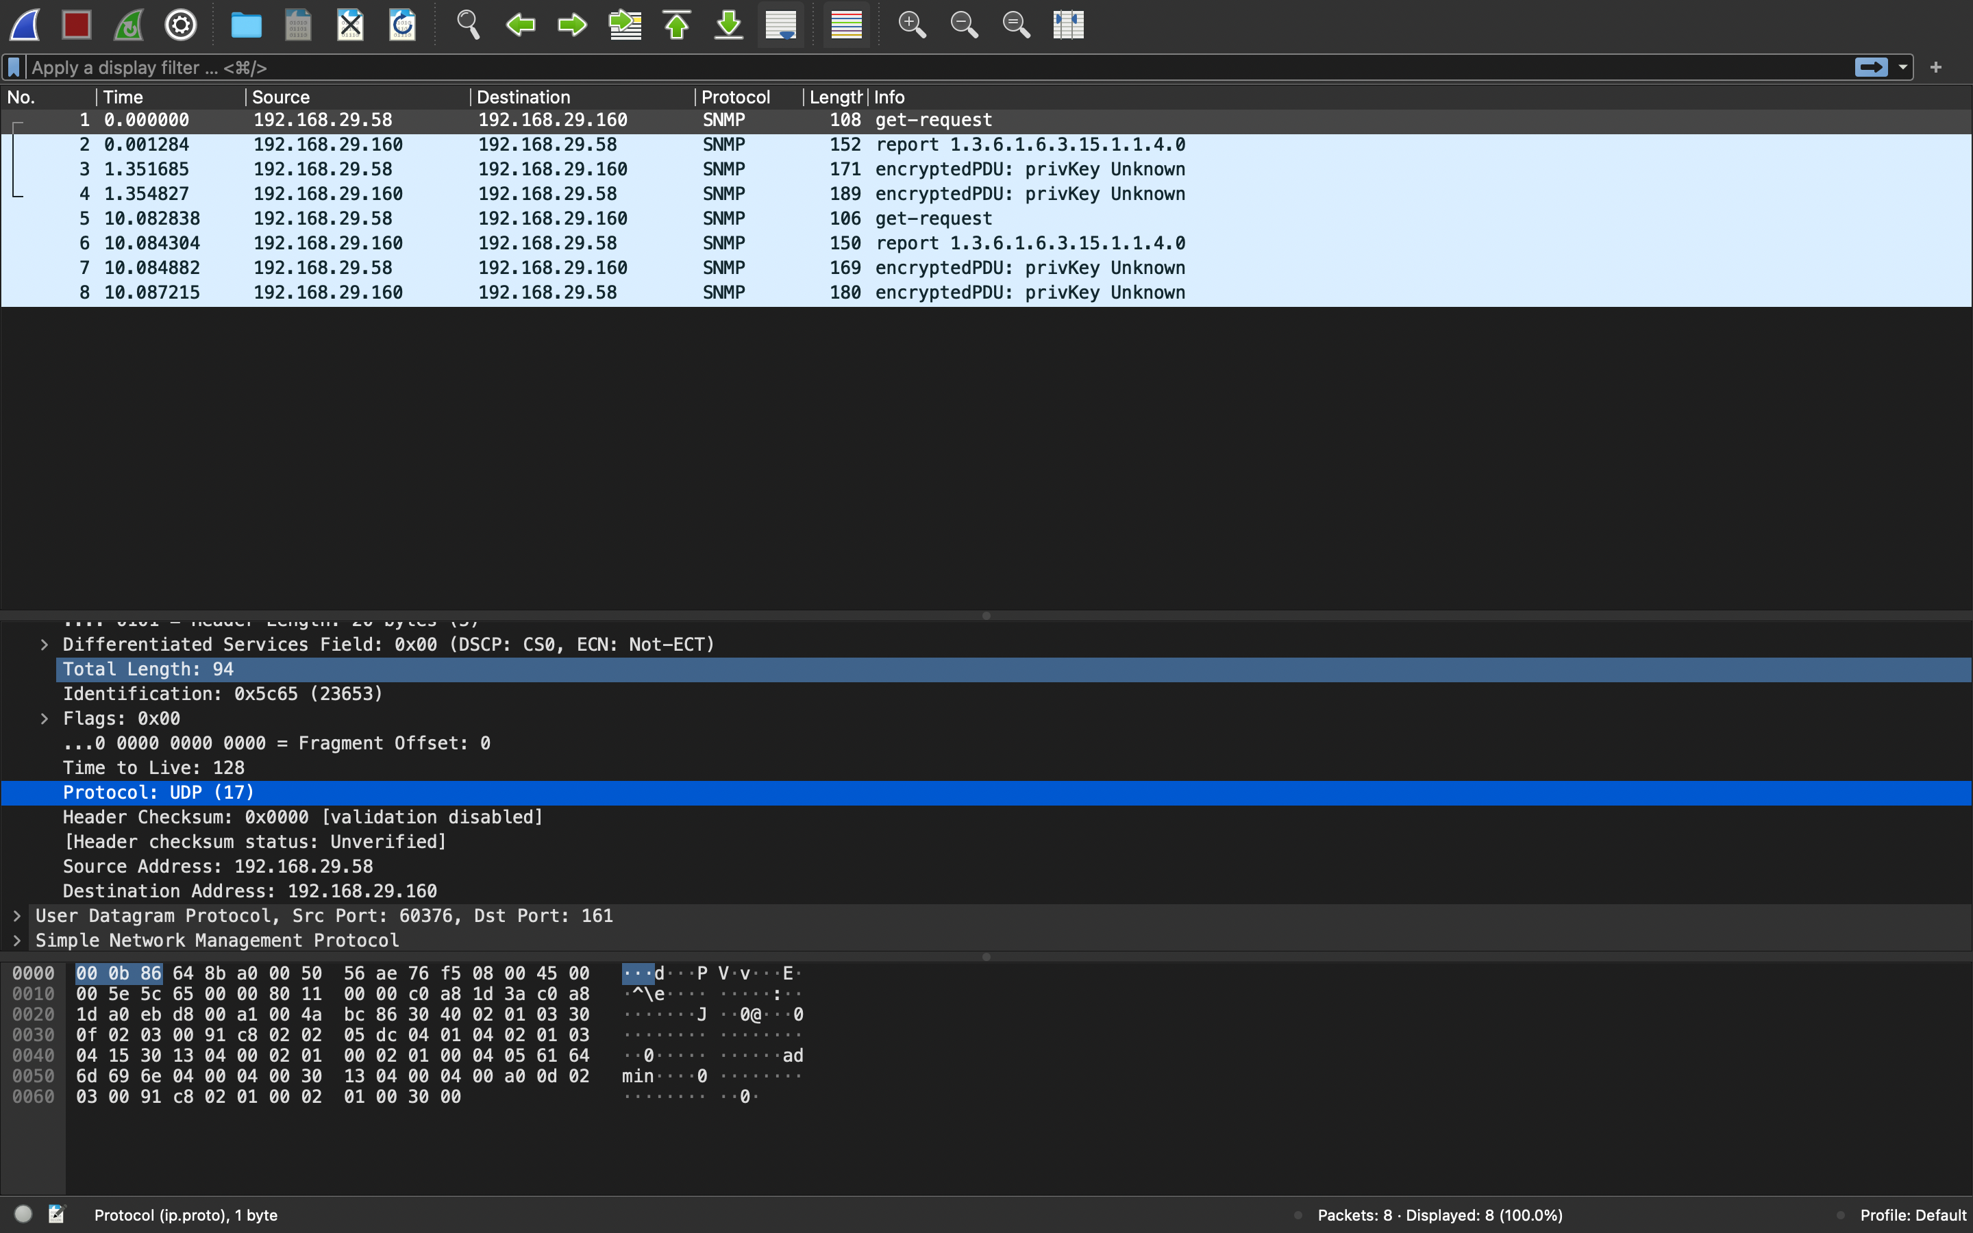

Section A, Question 2:

The SNMP uses UDP, Port 161 is connectionless and does not guarantee reliable communication. The common port is (53).

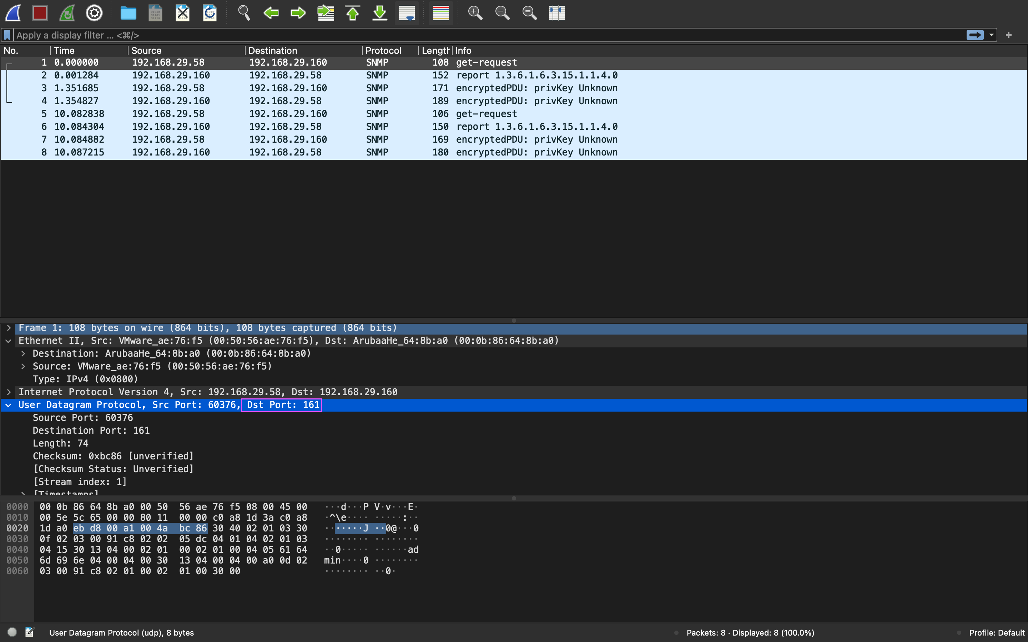

Section A, Question 3:

UDP on port 60376 provides an unreliable service and datagrams may arrive duplicated, out of order, or missing without notice.

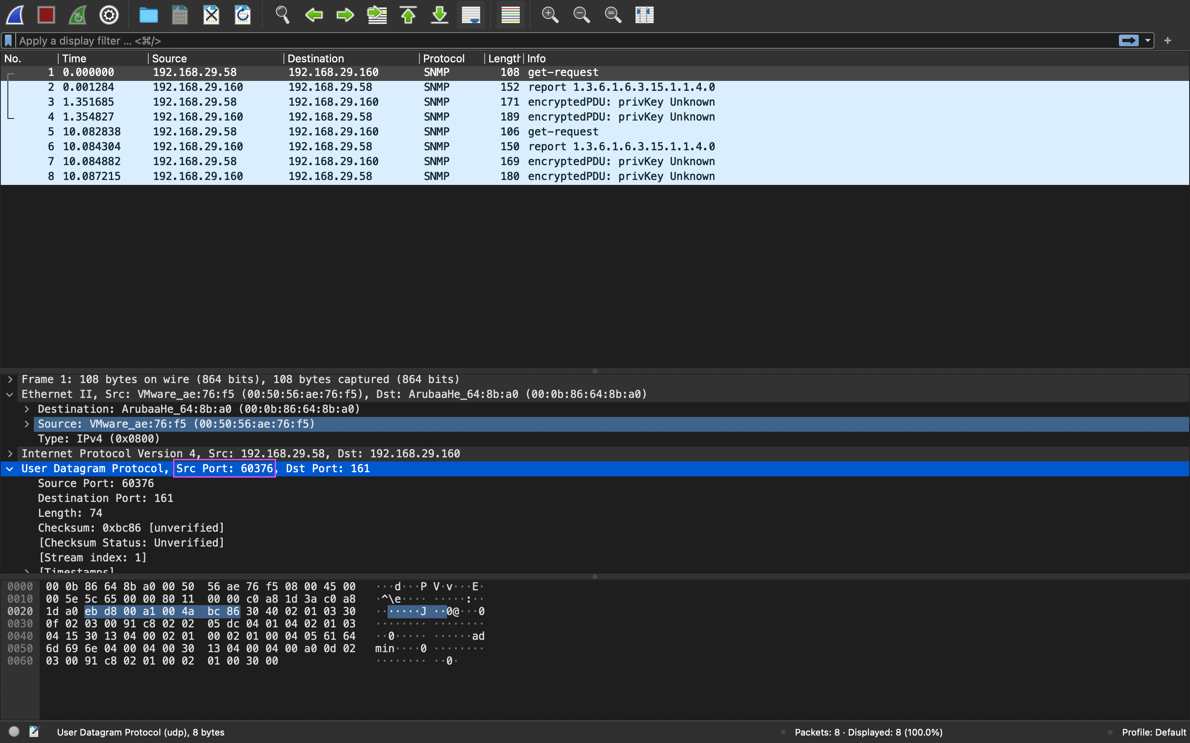

Section A, Question 4:

The port use is 161 for destination, which is connectionless.

Section B, Question 1:

The protocol being used is TCP.

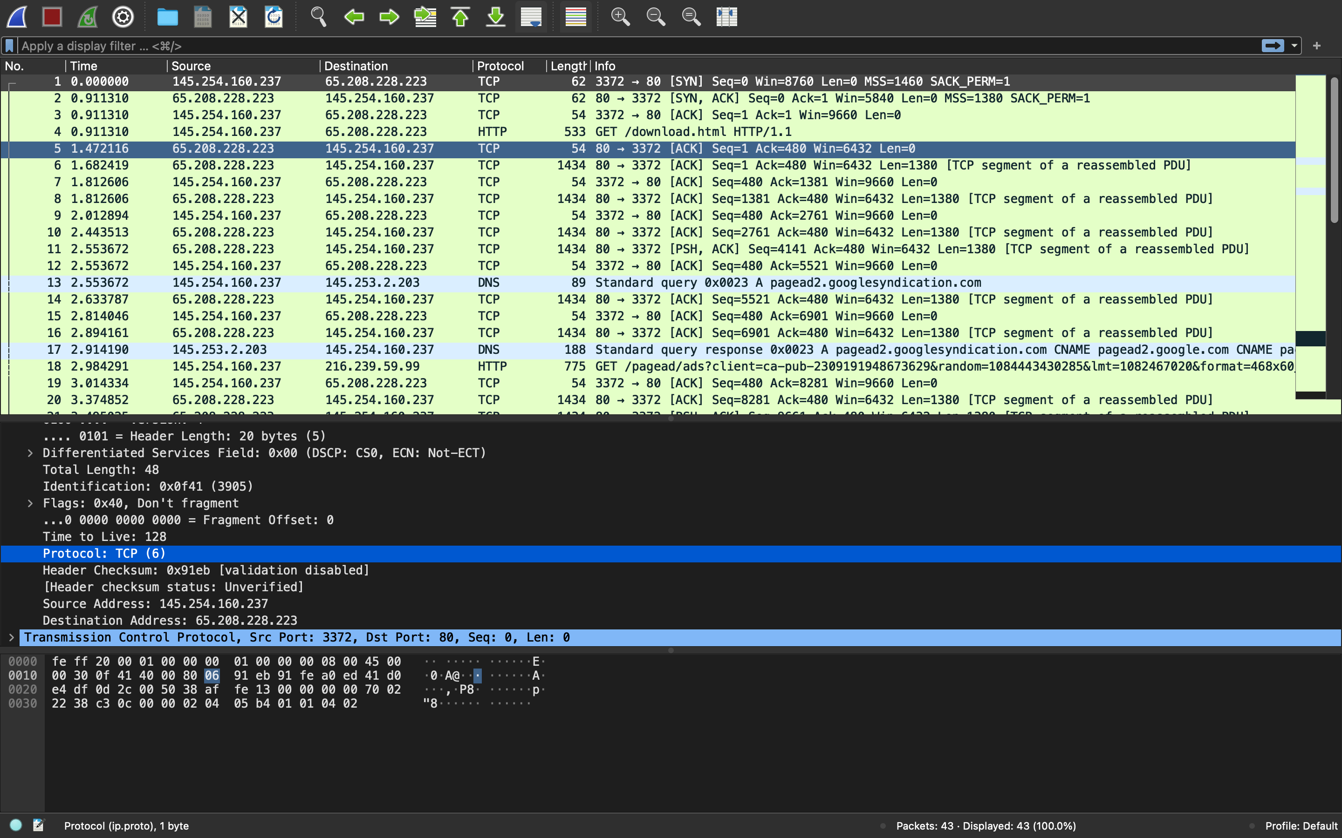

Section B, Question 2:

TCP port 80 is the common port for TCP.

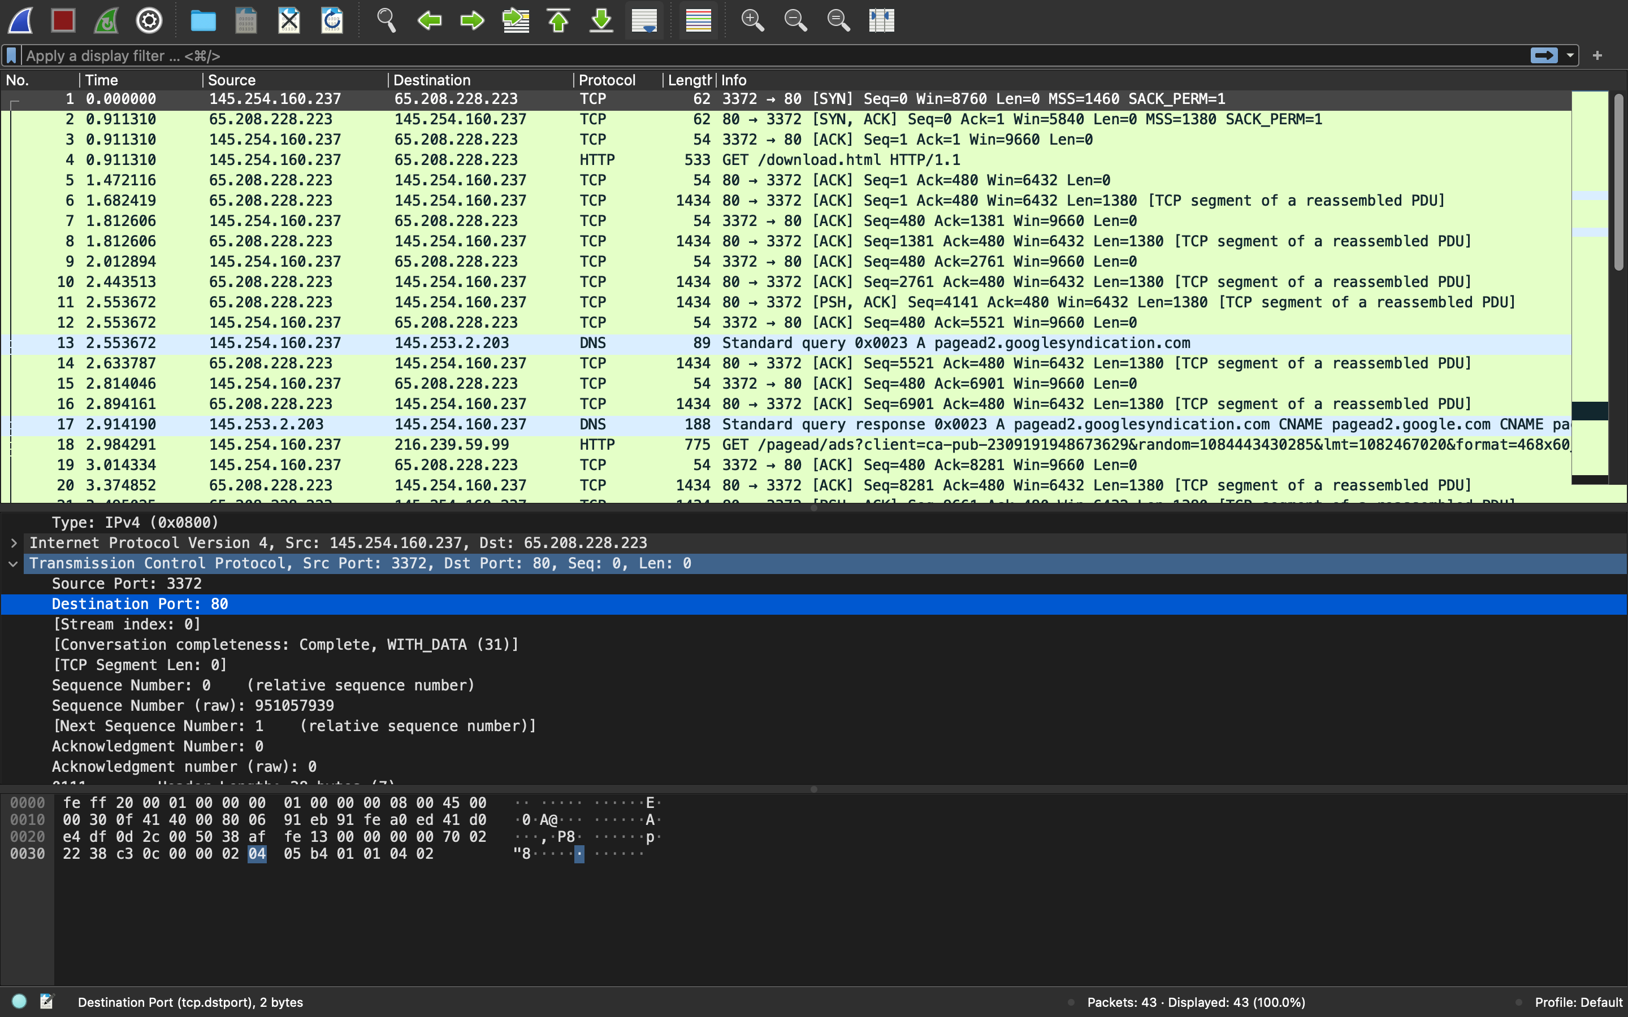

Section B, Question 3:

The port used is 3372, which is used for handshaking in this case. There is no significance

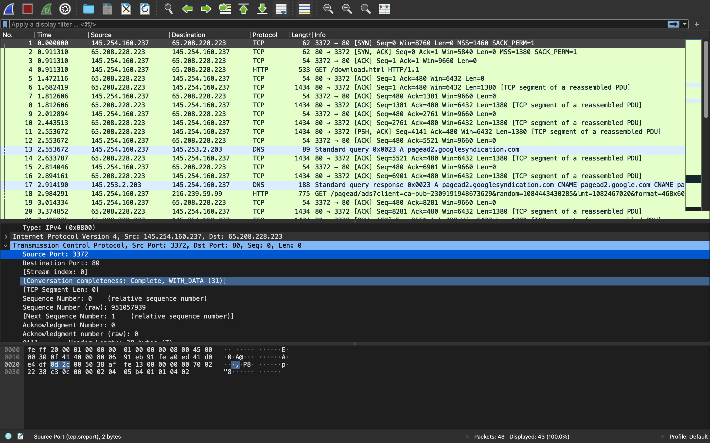

Section B, Question 4:

The flags set were SYN(Synchronized) and ACK(Acknowledgment). SYN is a step in the handshake process to tell the sender that it received its initial packet. ACK used to acknowledge the successful receipt of a packet.

